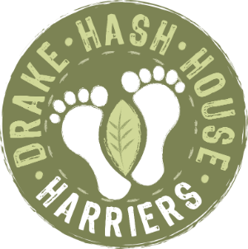
Drake Hash House Harriers
Grand Master: Crackle Snaffler
Hare Razor: Fitbit
Hash Cash: Pheregnome
Hash Tag: Good ‘n’ Ard
Hash Haberdash: Rover
Religious Advisor: Wimpout
drakeh3.co.uk
Upcoming Runs:
Date: 26th October 2020
Location: Dewerstone CP Shaugh Prior (SX533636)
On Down: n/a (or The White Thorn Inn, booked separately if you want to go, separate tables, following all covid rules as per government guidelines)
Post Mortem - Run # 1891
Hare(s): Crackle Snaffler
Hashers: Justin Thyme, Good‘n’Ard, Maid Marion, HT2, Endosperm, Phergnome, Goldfish (the fine ass), Gullybull, Beast, Fit Bit, Boot Basher, Trudi Scrumptious, Dead End, Ditch Diver - and anyone else I’ve forgotten because I didn’t keep a list!
Where: Harford Moor Gate
A veritable carcass of a hash began in style, with the official naming of two new members and the hare informing us that she needed to bog off by 8:30pm or she’d be for the chop at work. The hasher formally known as Jake, owing to his late-night escapades in the deep and shadowy troughs of Dartmoor, has now been named ‘Ditch Diver’. The GM was on a roll, and feasting on her newfound powers, also named Olly as ‘Dead End’, owing to his tendency to send his brain on a diverted route home and forget the road closures affecting his desired hash-bound route to Monday night ecstasy.
As ‘On on’ was called and the vaguest of directions given, the faithful found themselves struggling to decipher shit from shavings, but it all added to the fun. The FRB’s were greeted by a couple of beautiful back checks, gullies were descended and ascended with vigour and gnashing of teeth, and Goldfish performed a triple-piked somersault into a sea of gorse. Please be reassured that yours truly did help him up after the obligatory time spend laughing at his predicament. After an informal regroup, we made our way up some more moor, then back down again to the actual regroup.
As quality fare was passed around and the hare reminded us again of her work-related conundrum, we also learned that JT has a small one but Goldfish had a big one. We’re unsure what became of it thought! Sweets were duly scoffed and we steeled ourselves for the second half. But before we ran into the breech once again, Fitbit announced that Boot Basher had bashed her boots or booted her foot and could bash out a hash no more. A donkey was required, she declared, and the finest ass in the hash stepped forward. Goldfish, possibly regretting his altruism when he discovered how far we still were from the cars, merrily piggybacked the Basher and her Boots back down the hill, whilst the rest of us were spun a merry yarn into the depths of a bog most of us were unaware existed!
Foot, ankle, shin and knee all succumbed to the sludge, each hasher pushing themselves hard to outdo the stupidity of the last. Perhaps feeling the need to re-establish his prowess following his earlier discussion with ‘the hash’s finest ass’, JT took the prize for most impressive plunge, dunking himself fully to the waist like a hobnob in the Queen’s tea.
So back to the cars for someone to get the Bishop’s Finger and further discussion on what the hell this was…
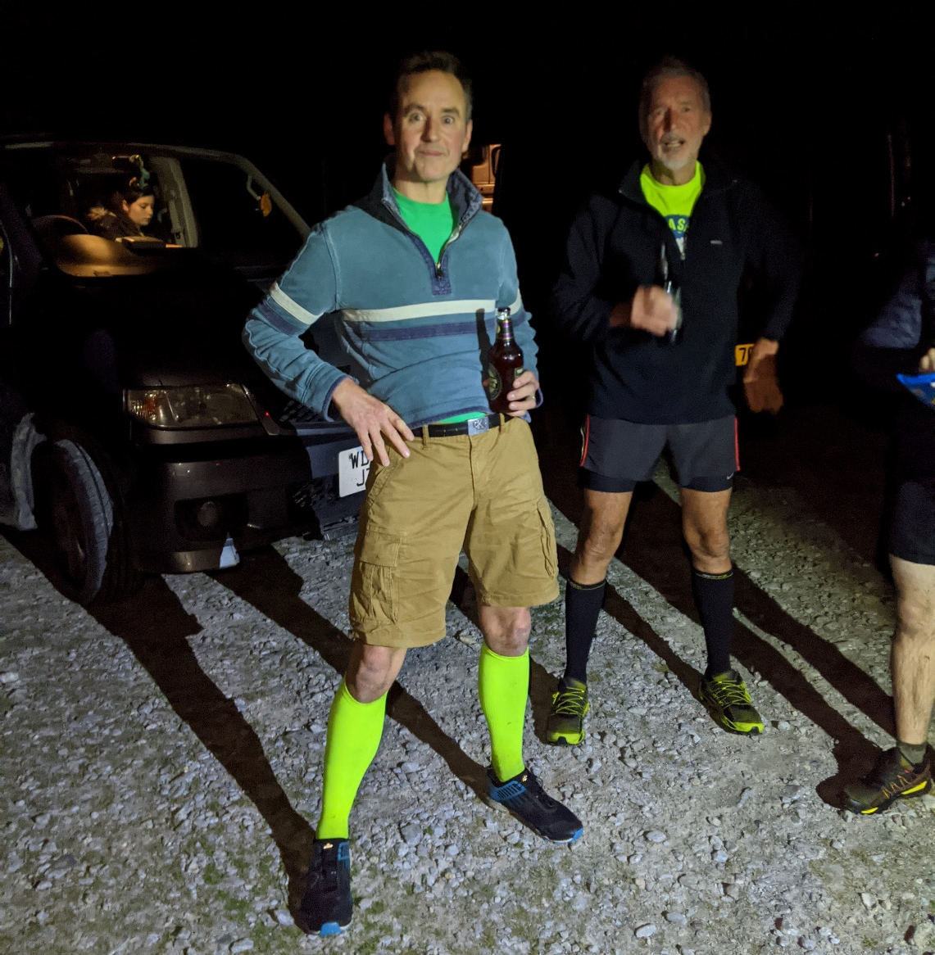
On on!
Good ‘n’ Ard

