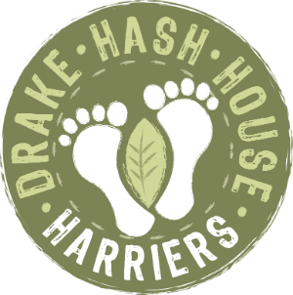
Drake Hash House Harriers
Grand Master: The Beast, Hair Razors: HT2 & Endo,
Embezzlement: Pheregnome, Hash Tag: Good ‘n’ ‘Ard,
Hasher-dabber: Rover, Religious Advisor: Wimpout
drakeh3.co.uk
Upcoming Run
Date: 2021 Oct 18
Hare : Loupy, Goldfish
Location : Whitehill Tor CP
On Down: Whitethorn TBC

Post Mortem - Run # 1920 AGM!!!
Hare: Crackle Snaffler, Fit Bit, Boot Basher, Loupy
Hashers: Yes Pub dwellers: them as well
Venue : Prints of Whales CP
Well this doesn't seem right, how can i be writing the words for a trail I helped lay? Must try to remember which hash has happened and which is yet to come...
I had planned a night in with a roaring fire and a whisky or two for company, but my liftshare had other ideas. Next thing I knew it was half five and I was in princetown discussing the cost and quality of sawdust these days. Tsk! And off we popped. Crackle was a very organised and enjoyable lay - we minions did her bidding, dashing about to shouts of ‘more sawdust!’ It was more like being in a snow storm at times.
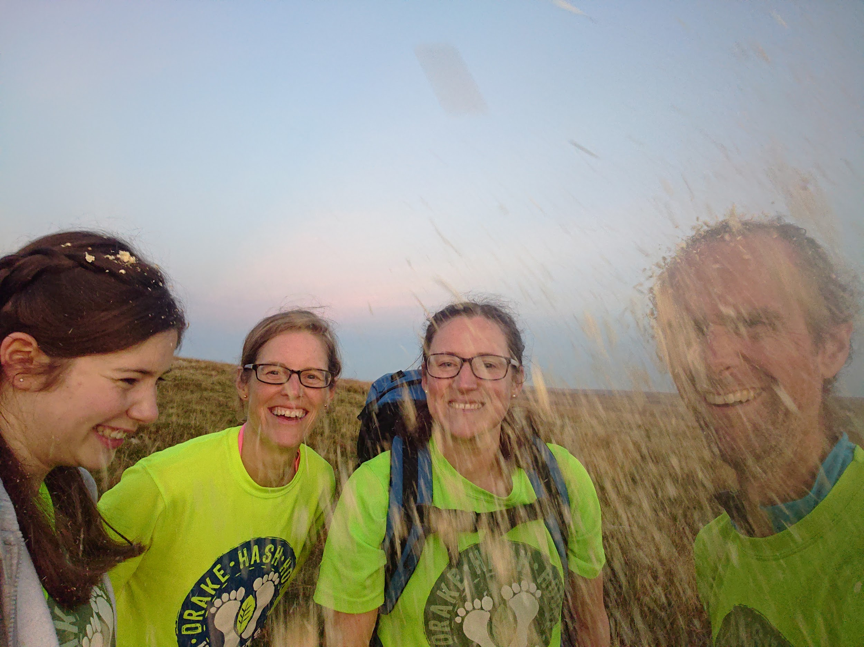
After a happy 90 minutes is was getting dark as we straggled back into Princetown tired, contented and ready for a pint and cheesy chips. Damn it! Got go around again with paying customers.

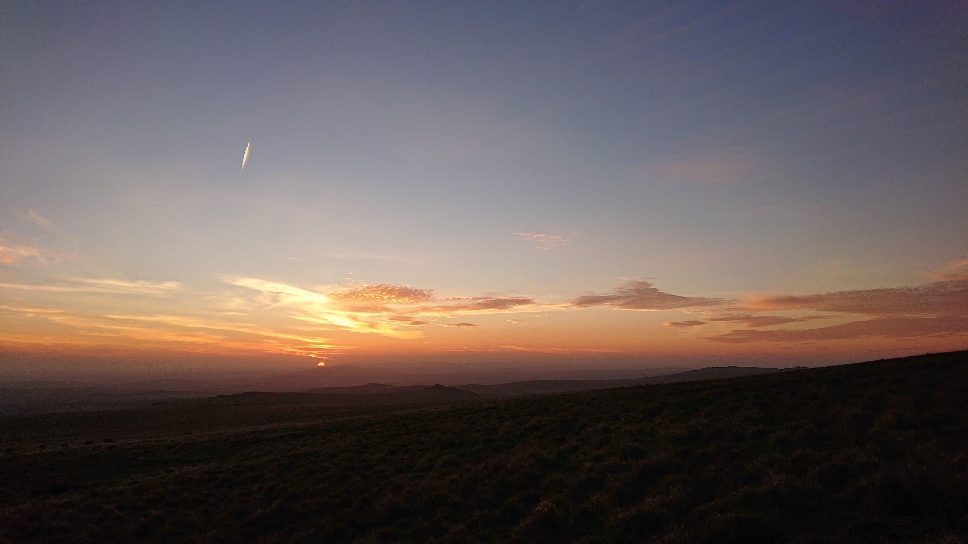
The throng of the great unwashed filled the Prints of Whales cp, well Rover was there. Maybe we were at the wrong venue? But no. Just a quiet night. By the time Goldfish handbraked in a shower of gravel we decided we were Quorate, as we had more than half the pack being non committee - ie there were enough victims to pass jobs too. How we laughed. Knowing that the outgoing GM always asks new committee members if they are happy to take the job…
Hash Hush was called, instructions given - sawdust, excuses given - ponies, wind, rain and escaped convicts and the pack were released! A quick trip to North Hessary followed for the less wary, whilst the scbs hopped and skipped round the hill to the RG. Sweets were proffered, but declined by the hounds who had the scent of cheesy chips. Confusion reigned briefly after the restart as Crackle swore blind that the trail went that way, but someone, Goldfish - who else, was calling on-on from the other. He was a tiny firefly speck in the distance by the time the outgoing GM agreed to her fallibility.
Once down at the rail track the frbs were sent on a soggy sprint down to a checkbackcheck by the road and a slog back. Meanwhile Booty set off to check. Got to the first spot of sawdust and was heard to shout ‘what do I do now?’ Followed by various abuse from more experienced time served hashers. It was a false trail. obvs. The really amusing thing was that she herself had laid it about an hour earlier!
With a final flourish the trail went for a lovely trip across the wobbly floating bog , the pack very vocally made their views known on the parcour.
Back in the welcome and warm embrace of the pub lean-to, beer was drunk, cheesy chips consumed and a fine speech made by our GM. And with a break from tradition she read it all by herself and didnt insist on everyone else reading it for it. Weird. Never catch on.
Post officialities, everyone was either grateful to be shot of that awful job, excited about their lovely new job or simply relieved to have been passed over by the great hash gods for another year. Well except for The Beast who appeared rather nonplussed with the turn of events, and looked like he was wishing he’d stayed at home with a roaring fire and a whisky or two for company.
THe GM is dead, long Live the GM!

