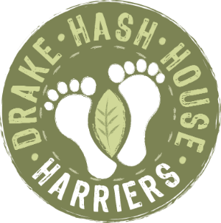
Dallas Has Her Helpers
Grand Master: Beast, Hare Razors:HT2 and Endosperm, Hash Cash: Pheregnome, Hash Tag: Good ‘n’ ‘Ard, Hash Haberdash: Rover, Religious Advisor:Go on, put yourself forward for this role!

drakeh3.co.uk
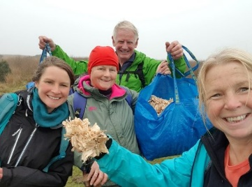
Upcoming Runs:
Date: 15/11/2021
Location: Lowrey Cross Carpark 546691
On Down: The Burrie
Post Mortem - Run # 1924
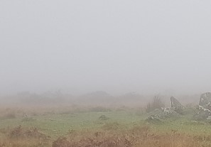
Hare(s): Woof Woof, Sawdust carriers Endo and HT2, PT sawdust sprinkler Dallas
Hashers/Walkers: HT2, Endo, Woof Woof, Crackle Snaffler, Spruce Goose, Boot Basher, Loupy, Goldfish, Pherognome, Dallas, Good N Ard, Just in Thyme, Boggsnaffler, Beast, Sugar Rush.
Pub Dweller: Rover
Where: Bowling Green carpark outside of Shaugh Prior.
Weather - clear excellent views on the recci, thick fog while laying, dry dark while running.
Having helped the hares lay part of the hash earlier in the day ( being enticed to do so by the promise of excellent views) I knew it was going to be a long one, and they didn’t disappoint!
As the ever-keen Hashers circled in the compact carpark for the hash hush, watches were checked, it was 7.29. but where was J T? Just as the clock turned 7.30 a screech of tyres and a blinding light sent the gathering scattering like skittles. J T had arrived. …Just -in- Thyme!
All the FRB’s were sent off first, Obviously in the wrong direction, just for the hell of it. This gave the bimblers, jogglers, walkers and wounded a chance to find the trail and get a head start. The sawdust shavings were clearly visible and it wasn’t long until the FRB’s zoomed past leaving them behind. Lots of loops, checks and check backs and good tracks to run on.
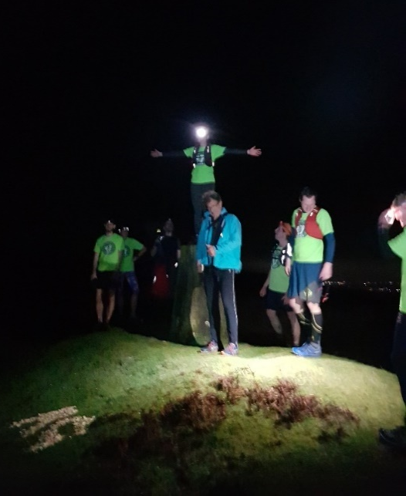

After half an hour of running, and seeing a clear RG in sawdust, we all eagerly awaited our rewards. Sugar Rush was keen to show off her newly fixed foot, and climbed the trig point to take Justin Thyme’s place as Christ the Redeemer.
Sadly, no sweeties were produced at this regroup, but a promise of something far greater at the real regroup later on. So on on we all went!

Short cutting FRB’s were seen flitting in all directions before their lights faded into the distance. Boot Basher and myself bimbled and joggled along, at such a speed the walkers and wounded overtook us and also disappeared into the distance.

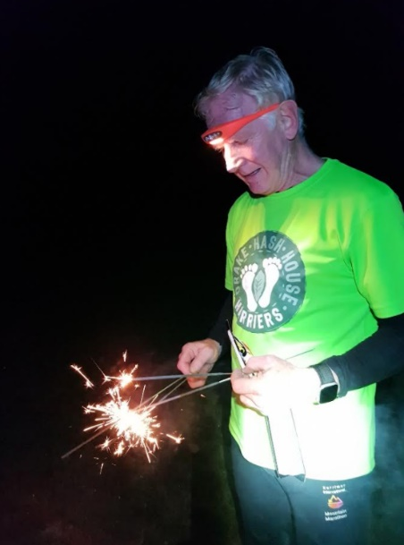
Arriving last (or so we thought) at the real re group sparklers and lots of pink edible goodies were shared and scoffed. when someone shouted where’s Sugar Rush? Whistles were blown and a full scale search party arranged, but all needlessly as Sugar Rush emerged from the darkness having spent time dancing naked round the fairy circle in some kind of paganistic ritual, Wondering what all the fuss was about and more importantly did we save her any sweeties!

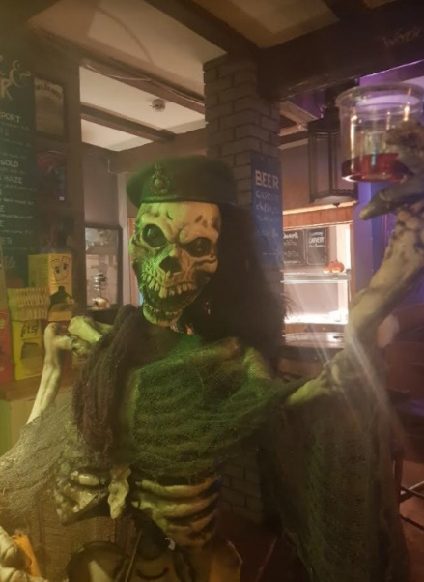

Arriving at the on down just before closing time we found Rover had been there for some time already!.

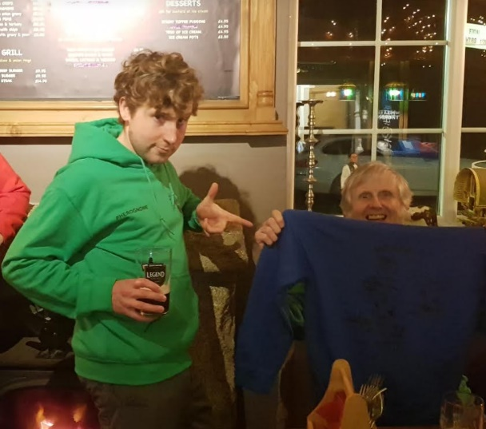
Huzzah!!! Long awaited hash hoodies were distributed …….. green being a very popular colour choice .
Cheesy chips consumed, beer and rattlers drunk.
Conversations heard and forgotten .
Though I do remember a concerned Loupy having a heart rate of 197! Think that was his way of saying it was a bloomin good hash! .
ON -ON
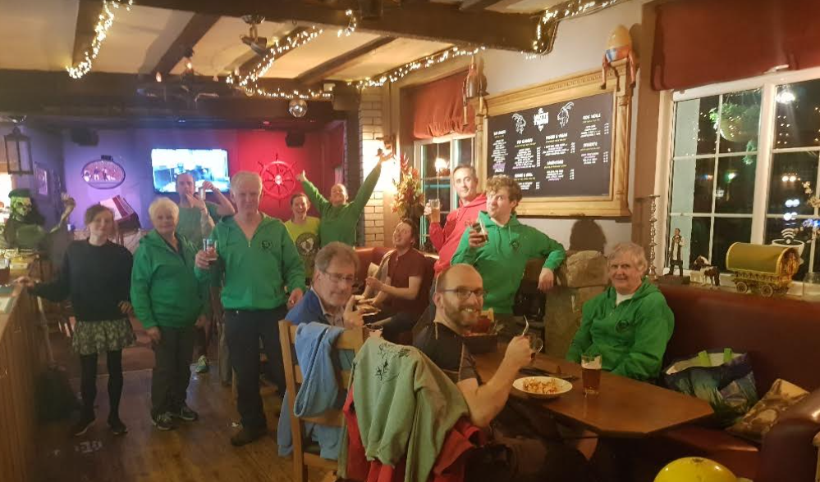
Dallas

