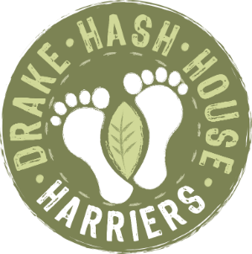
Drake Hash House Harriers
Grand Master: Crackle Snaffler
Hash Cash: Pherognome
Hare Razor: FitBit
drakeh3.co.uk
Upcoming Runs
Date: 6 Sept 2021
Where: TBC
What3Words: TBC
On Down: TBC
Post Mortem - Run 1913
Hare: Bog Snaffler
Hashers: Loupy, FitBit, HT2, Endo, Beast, Woof Woof, Goldfish, Dallas, Pherognome, Rover, GullyBull, Boot Basher, Wimpers, Wimp Out,
Where: Long Ash
Long Ash was the venue for Boggy’s very un-boggy Hash. He lead us a merry dance around the moor with, so I believe, some entirely pointless down’s just to ensure some equally pointless ups.
Oh such a dance that the Hare himself was lost on the way to the regroup leading two determined back runners through thorns and back again.
Now we did eventually make it to the regroup where Pherognome felt the need to climb a tree, the Hare felt the need to throw regroup sweeties at him and much comparison of leg injuries occurred. Goldfish won with actual trickles of the red stuff.
Greatly re-energised, off we set through yet more armpit high bracken to find a long short split and then a long run home.
All were safely gathered in when Dallas announced that she needed 800m more to get to her required 5km so in a most unusual fashion, it was the back runners who carried on running whilst the FRB’s dashed off to the pub.
Such fun was had at the Drake Manor Inn who provided top notch cheesy chips!
However discussions included: Eggs, toe sucking, Iraq, Ovaries, car accidents … you had to be there.
On On, FitBit

