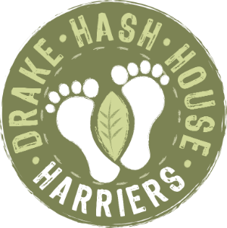
Drake Hash House Harriers
Grand Master: Crackle Snaffler, Hare Razor: Fitbit, Hash Cash: Pheregnome, Hash Tag: Good ‘n’ Ard, Hash Haberdash: Rover, Religious Advisor: Wimpout
drakeh3.co.uk
Upcoming Runs:
Date: 5th October 2020
Location: Norsworthy Bridge, Burrator
On Down: n/a (or Walkhampton Inn if booked)

Post Mortem - Run # 1888
Hare(s): Grizzly
Hashers: Endosperm, HT2, Phergnome, Dallas, Intit Deep, Gullybull, Bog Snaffler, Semi new guys – Trudi Scrumptious and Oli.
Where: Grenofen Bridge (SX490709)
The Words have been hastily writing from last week so apologises for my tardiness bit some pesky virus keeps interrupting my schedule!

The DHHH’s intrepid crew of 10 met in a rather boggy Grenofen Bridge Carpark. Misty, murky, muddy, perfect conditions for a hash. Rather concerning was HT2 reference to 69s! You will need to ask her about that… With biting flies dashing overhead, Grizzly lead the crew on a merry chase over the bridge and then multiple vertical non-paths darting over fallen trees. There were plenty of false trails and sheer quarry cliffs to avoid. Additionally, the kamikaze pheasants launching into one’s face, kept us preoccupied. But after skiing down the muddy banks to the re-group, a bag of wonderful chocolate eclairs and fudge sweets were presented, with glee from the Hare.

Successfully yomped down, the 2nd stage was from the stage on ninja warrior. There was plenty of ducking to low level branches and hopping over moss covered rocks, but unfortunately there was a rather embarrassing incident with Intit Deep. Squealing for help, a moss rock had decided to trap her hair and she flat on her back like a dying fly. Of course, we did not help but laughed and carried on. Chivalry remains high in the DHHH gang! Crossing the River Walkham a few times was refreshing and after a short dash, “on-home” was called. 10 minutes later Trudi and Oli arrived with Grizzly, somewhat wet and exhausted but looking very happy. A gaggle of hashers meet in the Walkhampton Inn for mandatory cheesy chips and beer. Whilst there, Intit Deep was explaining about the benefits of her Covid fitness regimen and apparently her personal trainer was regularly breaking her ass in the gym! Oh-er missus!!

A cracking run! On-on

